ANNUAL REPORT 2025-26
St John the Evangelist Hurst Green
May 2026

Welcome everyone, deepen faith,
inspire action and
share God’s friendship and love

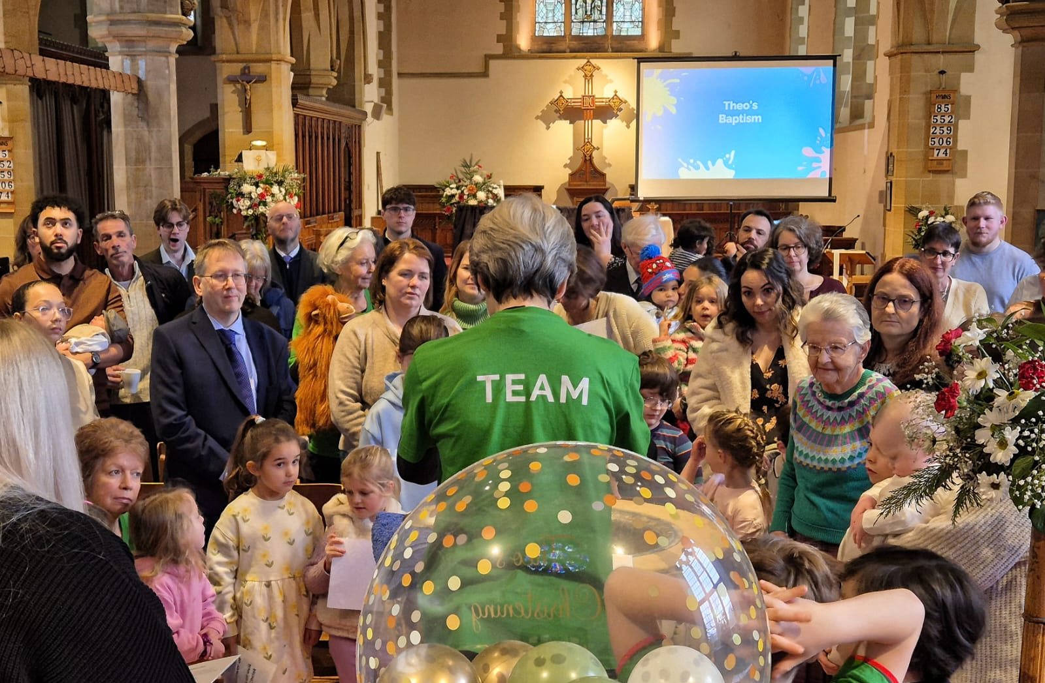

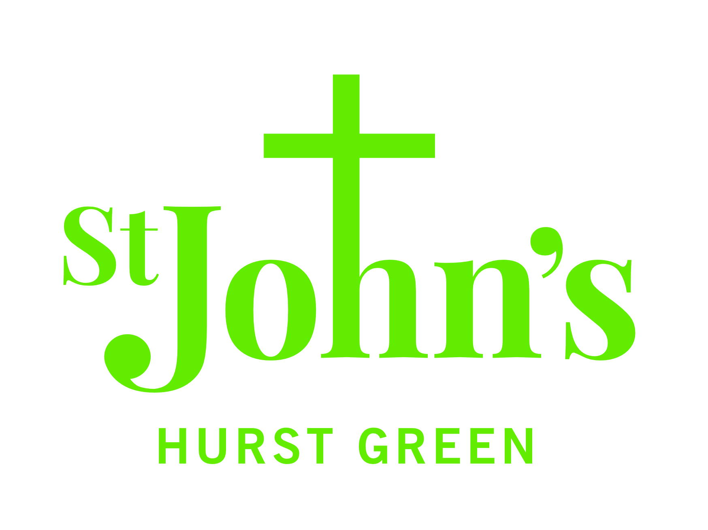
A Vicar’s Viewpoint
Now to him who is able to do immeasurably more than all we ask or imagine, according to his power that is at work within us. Ephesians 3:20

As I pause and take stock of the year that has passed since our last APCM, I give thanks to God for all the ways in which we can see his love, life and spirit working in and through us all as a church.

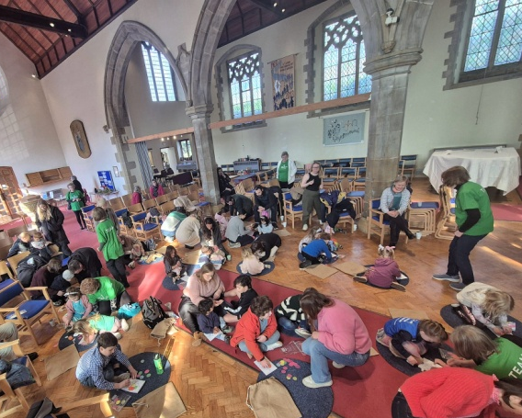
Thank you to everyone who offers their time, creativity and kindness in so many different ways; whether at church on Sundays, caring for the church and preparing for services during the week, leading a group or ministry and by keeping St John’s in your prayers.

What has also struck me most about the past year is how innovation and imagination have made such a positive impact on our mission to young families.

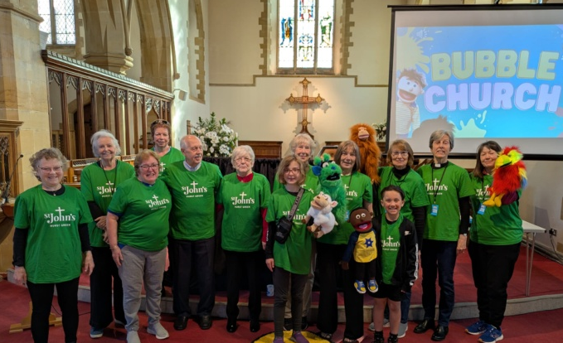
We started Bubble Church last April and have been delighted at the number of families who have been coming along. Since it started, we have met 18 new families and on average 15 families come along each month. The team has grown too, with 12 adults and 3 children who are regular members of the team. Bubble Church has given us a wonderful opportunity to share the Christian faith in an engaging and meaningful way with young and old alike.
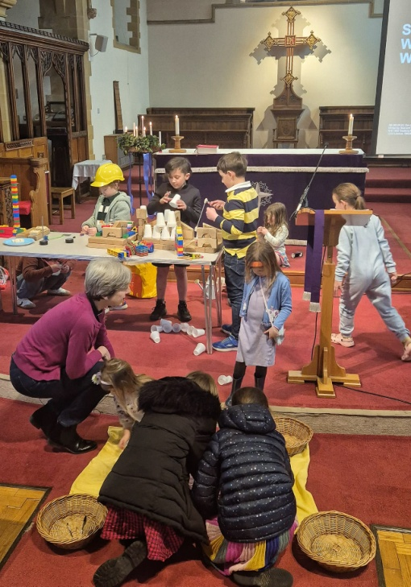
Many of the innovative ideas of Bubble Church have inspired the development of our all age worship. It’s been so encouraging to see many more families coming to this service and all generations taking part in the bible story, prayers and worship songs.

We have seen God at work among us in so many other ways, such as at the Lent course at St John’s, on Mondays at the GIFT group and in May some of the newer members of the congregation will be confirmed in a service at Southwark cathedral.

There are also challenges to face as a church family too. Our finances continue to be greatly stretched and we need engage with a wider demographic in the parish.

Let’s pray that God will show us how to approach our ongoing mission with the same innovation and imagination that has inspired us this year.

Most of all, may we trust God who has shown us more than we could have imagined in the past year and trust that his power continues to work within us all.

Revd Sue Bosley, Team Vicar

Churchwardens’ Report

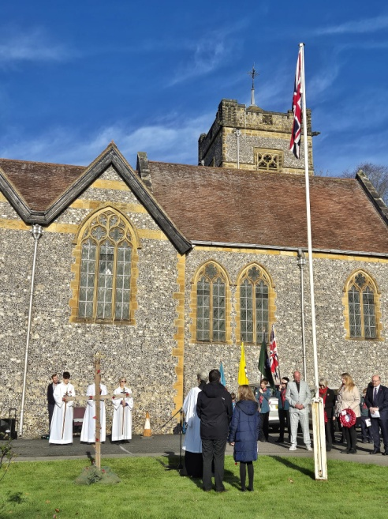
As I sit down to write this year’s report for the APCM, I am incredibly encouraged by the life flowing through St John’s. While we must be honest that regular Sunday attendance isn't always what it used to be, and we see the same general decline in weekly numbers that many parish churches across the country face, this is only a small part of our story. The truth is, we have seen some truly wonderful bright spots over the last twelve months. The introduction of Bubble Church has brought fantastic new life and fresh faces through our doors. Our major gatherings, like Remembrance Sunday and the Christmas services, remind us brilliantly just how much St John’s still means to the wider Hurst Green parish.

Because our mission as a "Church Without Walls" relies so heavily on welcoming those who might only cross our threshold occasionally, we need to look critically at the space we offer them. This is the driving force behind the changes we are making to the area around the font. When folks from the village join us, for example at the Christmas Carol Service, we need to be able to linger with them. Reorganising that space isn't just about shifting furniture; it is a vital re-ordering of our building to create a genuine, open area for hospitality. It gives us the room to hand someone a glass of mulled wine, to stand and chat with neighbours we normally never see, and to make sure new visitors feel they have the space to breathe and connect.

None of these vital changes would be possible without the incredible generosity of our congregation and supporters. This year, we have been remarkably blessed to receive some significant financial gifts, which have allowed us to take real, practical steps forward rather than just standing still. These generous contributions have funded the beautiful new cabinet at the back of the church and will cover the cost of moving the font. We anticipate that the work on the font will begin later in the summer.

Looking ahead, there is a real, renewed energy in our mission activities, and the coming year is shaping up to be an incredibly exciting time for St John's. We are stepping out with several new initiatives to truly live out our "Church Without Walls" calling. You can expect to see different styles of worship, including outdoor church services, alongside new types of community activities happening right here in the building, and even summer concerts. We are actively finding new ways to reach out and invite Hurst Green in, making sure our church remains a vibrant, beating heart of the village.

Of course, this vision relies entirely on the people who lead and support us. I want to express our deep gratitude to our Vicar, Sue. Since coming in, she has introduced so many wonderful new initiatives and has quickly become a key cornerstone not just for St John's, but for the wider Hurst Green community. Her relentless drive to reach out to the parish is a true inspiration to us all. We also owe a huge debt of thanks to Mary for her continued support and tireless drive. Not only does she lead us in beautiful worship on Sundays, but her dedicated pastoral ministry, particularly in leading funeral services, is an immense blessing. The care, grace, and comfort she brings to these services make a very real and lasting impact on the families and loved ones left behind.

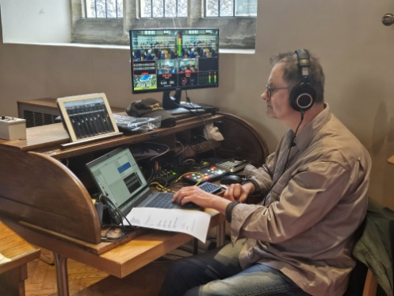
Finally, keeping our church running smoothly and safely requires a great deal of unseen effort. On the administrative side, I can confirm that in accordance with our legal duties, the Terrier, Inventory, and Logbook have all been checked and updated appropriately. I also want to extend a very special thank you to Julian, who is responsible for the financial management of St John’s. All his hard work, dedication, and meticulous oversight are absolutely vital to the life and stability of our church, and we are deeply grateful for the heavy lifting he does quietly on our behalf. But beyond the paperwork and finances, keeping our church a place where people actually want to gather, takes a staggering amount of behind-the-scenes practical work. Because this work happens quietly, it often goes without the recognition it truly deserves. I want to specifically highlight our cleaning teams, who constantly ensure the church is spotless and welcoming, our coffee making teams, who provide such vital and warm hospitality week after week, alongside our incredibly dedicated flower arrangers. The sheer amount of time, hard work, and creativity poured into those floral displays brings a wonderful sense of beauty and care to our building. To everyone who sweeps a floor, arranges a display, hands out a service sheet, or makes a cup of tea: thank you. Your hard work is the quiet engine of St John’s, and we are deeply grateful for everything you do.
Henk van den Berg, Churchwarden
Formalities and Legalities

The Parochial Church Council (PCC)
The PCC is the legal governing body of a parish; it is a charity and its members (currently fourteen) are charity trustees. They are required to undertake safeguarding training and, together with the Vicar, who chairs meetings, must make decisions on every aspect of church life. This includes safeguarding, which features on every agenda, spiritual and practical oversight, finance and budgeting, care and maintenance of church buildings and grounds, and making connections with the local community and wider church.
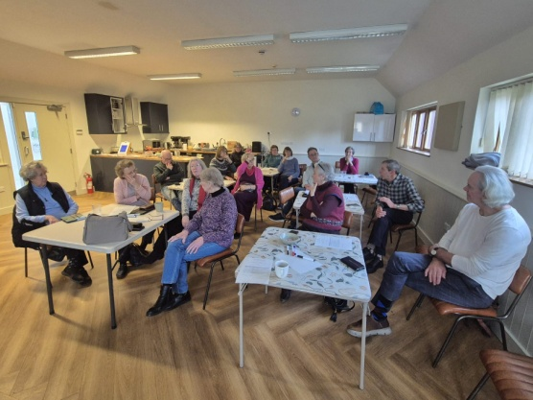
During the year mission has continued as a major theme and everyone was invited to join PCC members at The_Space, Oxted Community Hall in January, for a special day (lunch included!) to develop our mission at St John’s. The day was very positive, creative and productive, with a variety of ideas emerging. These involved activities aimed at building and strengthening relationships and connections, both with other church members and the local community, and making St John’s Church more visible.

Joining the PCC is a good way to get to know people better and to participate in the decision-making process of your church. You are encouraged to consider standing for one of the PCC vacancies on 10 May. To find out more, please speak to any of the current PCC members; names and photos are on the porch noticeboard. The PCC meets five times a year on Thursdays at 7.30pm in the York Rooms; attending by Zoom is always offered as an option. The next meeting is on 2 July 2026.

Janet Harman, PCC Secretary

Tandridge Deanery Synod
A Deanery is a group of Church of England parishes in a geographical area, which work together supporting each other; it creates a bridge with the Diocese and wider church. Deanery Synods, the formal meetings, include all licensed clergy and lay members elected by their parishes. They focus on mission and ministry and mutual areas of concern and interest, providing a channel to share information. Deanery Synod members form the electorate for Diocesan and General Synod elections, the latter to take place in autumn 2026. Becoming elected to a Deanery Synod is therefore significant both locally and for the wider Church.

Tandridge Deanery Synod is led by Area Dean, Revd Michelle Edmonds, Assistant Area Dean, Revd James Ashton and Lay Chair, Susan Gibbin, who also acted as secretary until the appointment of Maria Foulkes. During the past year some new ways of working have been tried, with shorter business meetings held on Zoom, the development of collective worship and prayer, and holding services or events for all church members, not just Deanery Synod representatives. This included a very special service at St John’s in October 2025 to mark Black History Month. The second ‘Picnic in the field’ will take place on Sunday 21 June 2026, 12.30 - 3pm in the Glebe field at Tandridge.

All lay Deanery Synod representatives finish this year, and new ones must be elected (or existing ones re-elected) for the next 3-year term. St John’s is entitled to three representatives. Please consider standing for election. Pick up a leaflet from the church to find out more or speak to a current representative: Sue Bosley, Janet Harman or Liz Parker. St John’s is always a popular place to meet due to its excellent facilities (parking and toilets) and will be the venue for the next meeting on Wednesday 24 June 2026.

Janet Harman, Deanery Synod representative
Pastoralia
Sadly, we have had to say goodbye several of our church members who have passed away this year: Stephen Mills, Derek Say, Brian Brackpool, Sylvia Russell and Beryl Perry. They were lovely and gifted people who shared their talents most generously with us, and were most faithful in worship over the years. Each one contributed to the richness of our communal life. We thank God for giving them to us, and that we knew them.

A number of people from the wider community passed on too, and we at St John’s were privileged to participate in their farewells: Mary Saunders, Bryan Parsons, Dinah Walker, Margaret Bamford, Sheila Geal, Kathleen Humphrey, Gillian Botley, Pat Browne and Gerry Carpenter. Each one, in their own way, was active in service to others, and made a difference to the world in which they circulated. We thank God for them too.

The mortal remains of Brian and Joan Brackpool were interred in our Memorial Garden exactly 70 years to the day after they were married at St John’s. May all these dear people rest in peace. We offer our condolences to their families and friends who sorely miss them.

After Stephen Mills died, Janet decided to move away to be nearer her daughters in Oxford, and we miss her sprightly and loving presence. Roger and Chuck Lugg moved from their home overlooking the church to live in Edenbridge Manor Care Home. Cathy Booth, our long serving Churchwarden, and Geoff, our long serving Churchwarden’s husband and our church wages manager and financial advisor, moved to a village in Gloucestershire. We thank them both for their prodigious input to the smooth running of our church for so many years. We wish them, and Janet, Chuck and Roger happiness in their new homes.

Our oldest former parishioner, Elizabeth Herbert, now resident in Sycamore Court, Oxted, celebrated her 102nd birthday in March. She has had an up and down year, including two spells in hospital. But on her birthday, she was as perky and upbeat as ever. Her only comment about ‘age’ was that every time she looks down at her hands, she can’t believe that they are 102 years old!

Revd Professor Mary Seller, Assistant Priest

Fabric

The regular annual maintenance work, which includes servicing and inspections of such items as gas/boilers, fire alarms, PAT, etc, revealed that a number of the church's emergency lights needed replacement, because their batteries were failing. These have been replaced; another batch of lights will require replacement in 2026.

Several large patches of render on the external walls of the York Rooms had degraded and so remedial work has been done. At year-end there remained some painting and minor high level repair work to complete - this has subsequently been done.

We experienced some storm damage involving the breaking of several stain-glass window panes. Fortunately these are simple coloured panes and are being replaced under our insurance.

We have progressed with the planning of moving the Font; this is being moved from the centre to the side of the main aisle, in order to improve the usability of the space. The work is planned for mid-2026.

Other minor work has included:
- Ordering and fitting a second St John’s sign/map board outside Aggies
- Repairing various items of damaged furniture
- Replacing various lights with LEDs
- Minor plumbing repairs
- Fitting a replacement door lock, and new key-safes

Unfortunately the church has experienced several minor incidents of theft and attempted theft, so we are looking at improving our CCTV security camera capability. The current system is very dated. Quotes were obtained to allow alternative options to be assessed, and funding options are now being looked into.

Grounds

Grounds
- Extensive tree-management work has been undertaken to ensure tree-health and safety in the church grounds.

Chris Johns

Finances

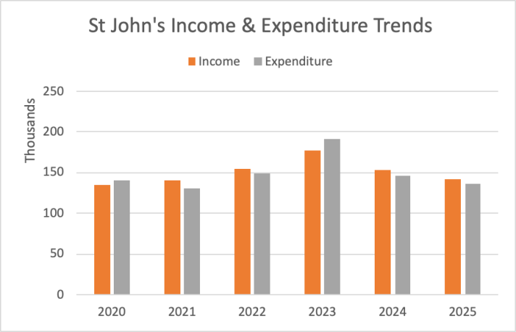
Headlines for 2025
For 2025 the PCC showed a drop in both income and expenditure, to £142K (2024: £153K) and £136K (2024: £146K) respectively. This resulted in an operational surplus of £7K for the year (same as 2024).

Disappointingly, Planned Giving continued its downward trend to £58K (2024: £64K), with people stopping through passing away, leaving the area or other circumstances, or just reducing through cost of living pressures. Our regular giving campaign that ran in parallel with the 2025 electoral roll renewal generated some new joiners and increased pledges but this was insufficient to compensate for the losses. However, the drop was partly offset by an increase in other Giving to £17K (2024: £12K).

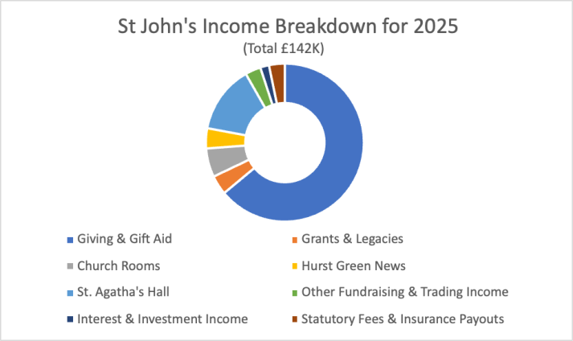
Grants & Legacies were £6K (2024: £9K), made up of small grants for the community activities that we carry out in St Agatha’s Hall, £1.5K for starting Bubble Church, and a £2K legacies from the wills of a former parishioner.

Activities for Generating Funds continued to grow with an improvement to £39K (2024: £37K). Church Rooms hires were up £2K to £8K and Fundraising income up £2K to £5K, offsetting a decline in St Agatha’s, down £2K to £20K. Hurst Green News advertising remained unchanged at £6K.

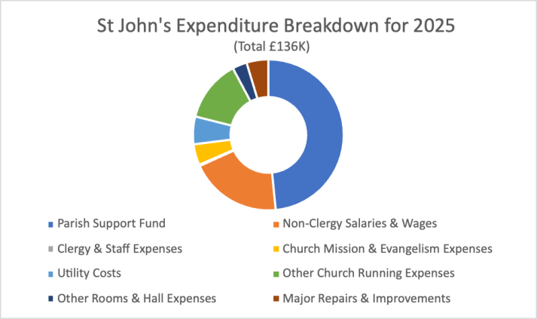
Statutory Fees Retained showed a small decline but remained at £5K.

The Parish Support Fund remains our largest item of expenditure, and continuing to be mindful of declining regular giving, the PCC agreed a 0.5% increase to £65.8K.

This was followed by Non-Clergy Salaries at £27K (2024: £33K), down £6K with our not replacing the Youth Worker after the associated grant ended in July 2024.

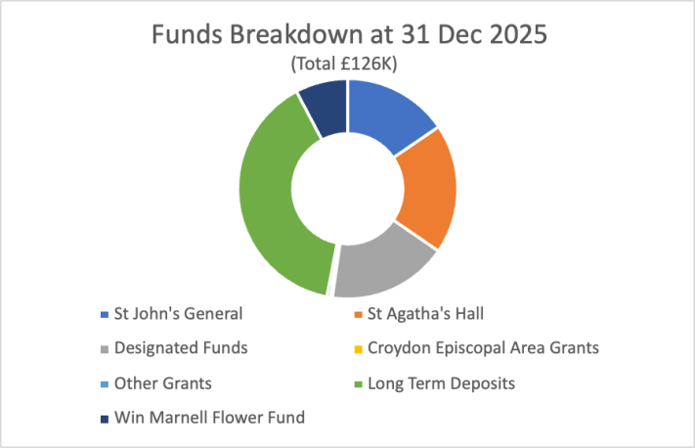
Other PCC running expenses were £35K (2024: £34K), of which the biggest item were Utilities £8K, up £4K from an artificially low 2024 because of the water leak refund. Insurance and Building Maintenance & Minor Repairs were £5K (2024: £5K) and £4K (2024: £7K) respectively.

Major Repairs were £5K (2024: £3K) being tree safety works in the grounds.

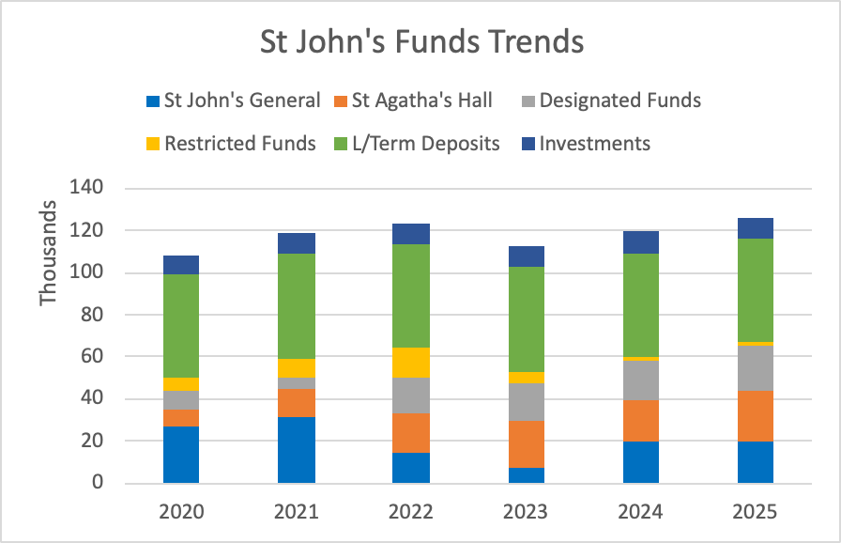
Income of £0.3K (2024: £0.3K) from the Win Marnell Flower Fund met nearly half the total flower costs for the year of £0.7K (2024: £0.5K). The underlying investment showed a decline in value this year of £(0.4)K (2024: gain £0.2K).

The Operational surplus less the investment decline resulted in a £6K increase in Net Funds, from £120K to £126K at the end of December 2025.

Looking forward to 2026
The decline in the amount given by regular giving looks set to continue based on information already received from donors, so with this in mind a prudent budget was set for 2026. Certain items of discretionary non-urgent expenditure for the church building (CCTV, other electrical issues and decorating) have been put on hold until suitable funding is available.

To help mitigate the shortfall, additional emphasis will be placed on securing income from other sources over and above St Agatha’s Hall and Church Rooms bookings, in particular, additional fundraising events and encouraging giving by visitors to the church. These plans will be worked on as the year progresses but at the time of setting the budget were not in place, so we forecast a drop in income of £(8)K to £134K. Any grants and unanticipated 1-off donations will of course increase the income.

Mindful of several prior years of below recommended increases to the Parish Support Fund, for this year the Finance Committee recommended, and PCC agreed, a 3.0% increase in pledge to £67.8K.

Salaries, our second biggest item of expenditure, are forecast to be £1K higher at £28K with a 2.5% inflation uplift being applied from January 2026. All employees are ahead of the National Living Wage though some are now below the hourly rate for “Real” Living Wage.

With committed and likely expenditure on building and grounds (excluding the discretionary items mentioned above), total expenditure for 2026 is forecast at £148K, resulting in a deficit of £(13)K for the coming year, with Net Funds ending at £112K.

Deficits such as this cannot be sustained, so please do support St John’s with fundraising (all suggestions welcome for new events!), hiring our facilities and donations when you are able.

Thanks again to Alison Richardson as St Agatha's Treasurer and running the Hurst Green News finances, Helen Ainsworth for Regular Giving and Gift Aid duties (but who has moved away and will sadly be stepping down from 2026), and Barbara Forrest for examining the accounts (and has agreed to continue).

Julian Taylor, Hon. Treasurer; April 2026

